**Configuration management:**

1. **GitHub:**

GitHub is an online version control service which stores our work in versioned fashion. We can revert to any version at any point in time. Multiple users can use a repository to store their work.

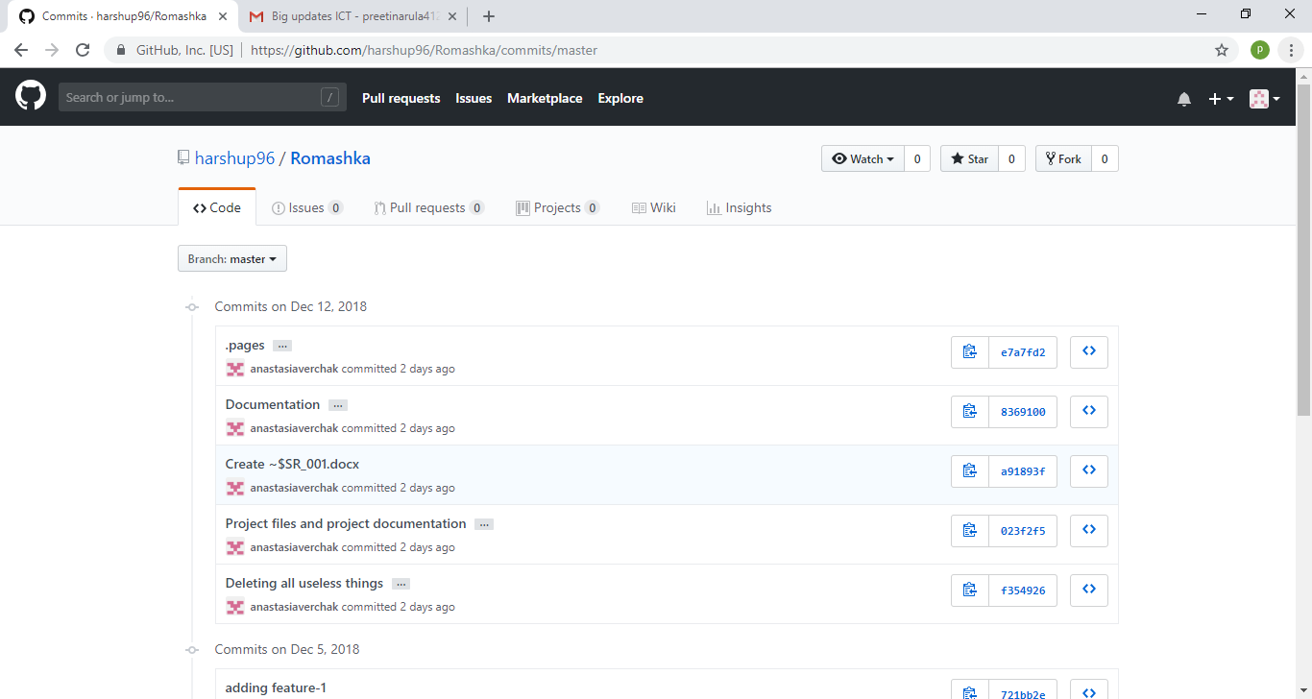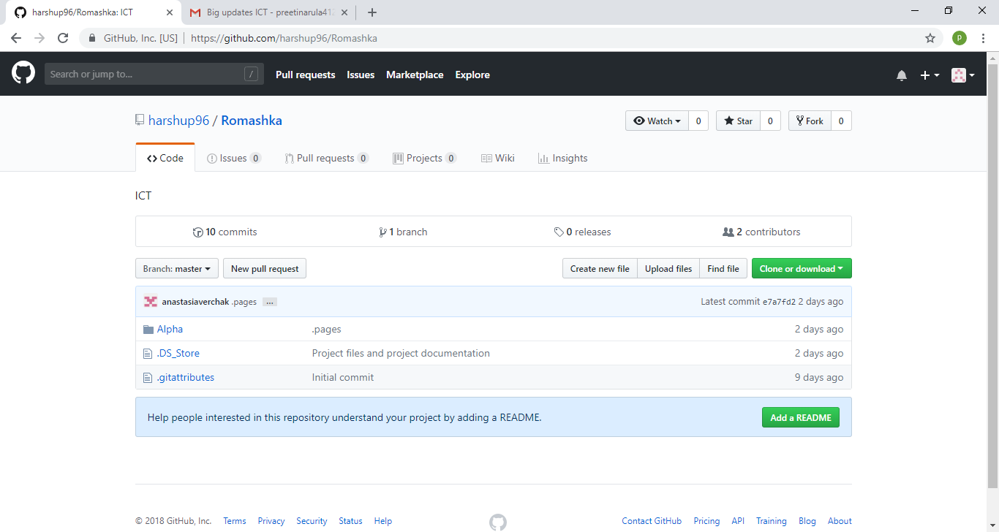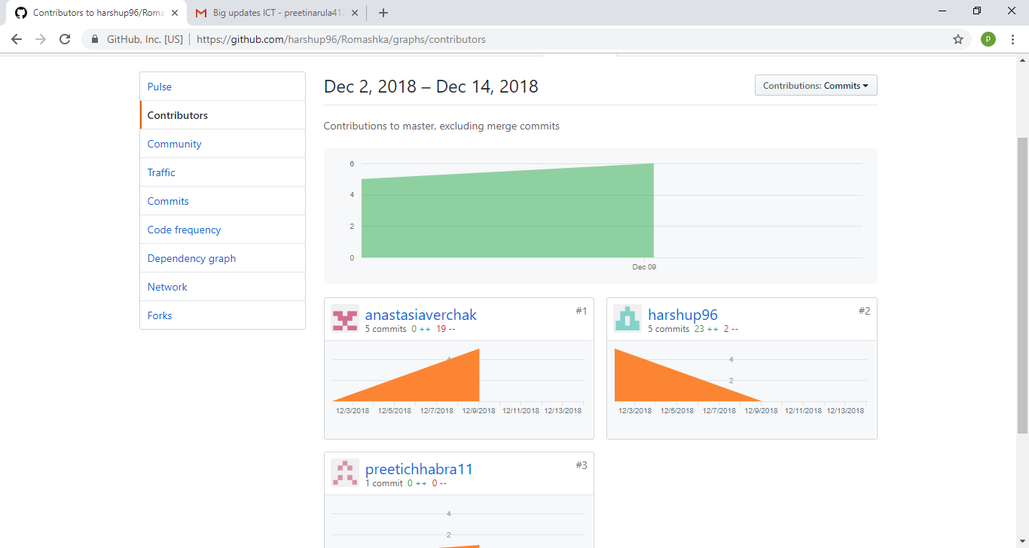

**Project Tools:**

1. **Adobe Dreamweaver:**

It is a comprehensive tool developed by Adobe for web designers. We used Dreamweaver for designing our HTML and CSS pages. The integration with Git makes it flawless. It also supports JavaScript, PhP.

c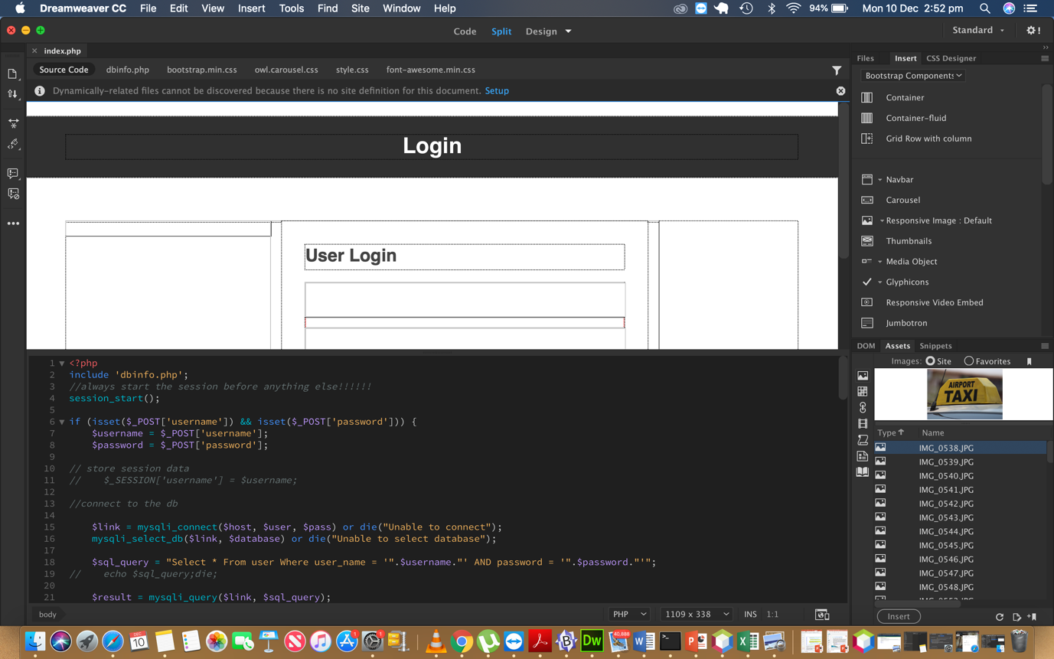

1. **PHP**: PHP is a server side scripting language that is embedded in HTML. It is integrated with number of popular databases like MySQL, Oracle, PostgreSQL, Informix, etc.

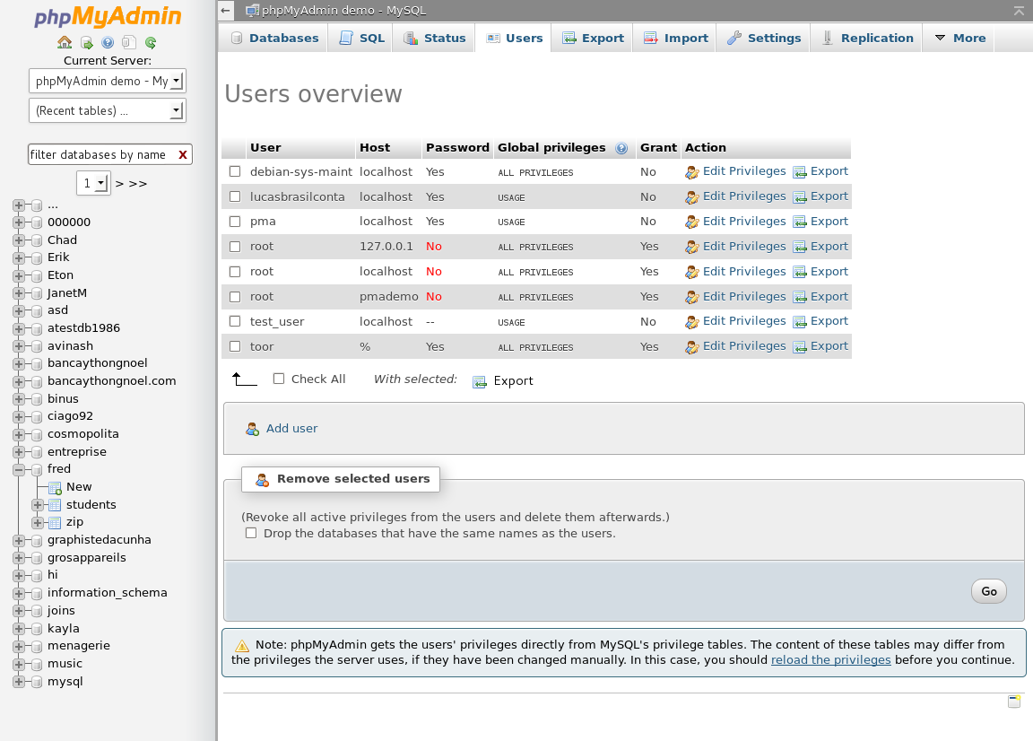

1. **HTML:**

HTML stands for Hypertext Markup Language. It supports tags for various elements of a web page.

1. **CSS:**

CSS is basically a styling language. It works in tandem with HTML for create beautiful webpages.



1. MySql:

MySql is a sequential programming language which helps in creating, managing and retrieving data from databases. We are using Microsoft access to implement our databases.

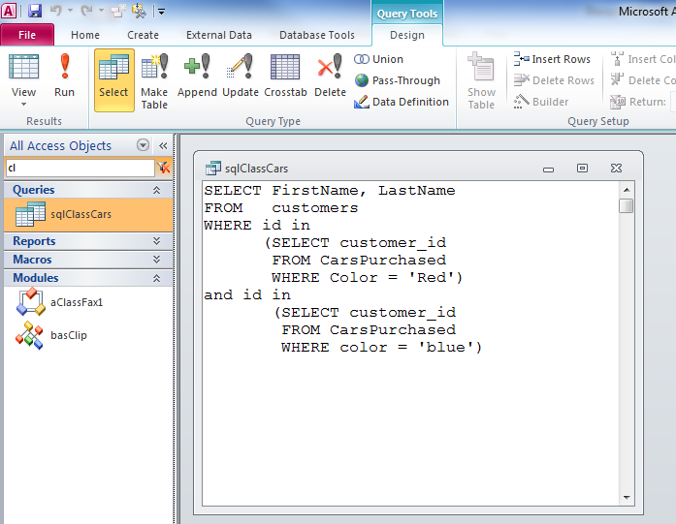

If a new team member adds up in later phases, they have to install Dreamweaver, Access on their laptops. The previously developed versions can be found on git. The new team member should understand our progress and be able to learn programming needed. He/she should be able to understand the user stories and priorities.

**Milestones:**

**Milestone 1**

|  |  |  |  |
| --- | --- | --- | --- |
| User story | Priority |  | Time frame |
| Home page | 10 |  | 26/11/18 – 05/12/18 |
| Login page(student) | 10 |  |
| Login page(staff) | 10 |  |
| Dashboard | 10 |  |

**Milestone 2:**

|  |  |  |  |
| --- | --- | --- | --- |
| User story | Priority | Estimated days | Time frame |
| Confirmation page | 20 | 5 |  |
| Payment page | 20 | 5 |
| First selection page | 20 | 5 |
| Edit selection page | 20 | 5 |

**Milestone 3**:

According to given timeline, the schedule looks little ambitious as we have limited knowledge in certain technologies where there is a learning curve but, with combination of execution and communication we are sure that we can finish the project on time. z

|  |  |  |  |
| --- | --- | --- | --- |
| User story | Priority |  | Time frame |
| About Us page | 20 |  | 16/12/18 – 01/01/19 |
| Contact Us page | 20 |  |
| Blog(Admin) | 40 |  |
| Event page | 40 |  |
| Blog (visitor) | 50 |  |

Github link:

<https://github.com/harshup96/Romashka>